FEATHERS in BIRDS
Of all the exoskeletal structures feathers are most important. Birds possess feathers and only birds possess them. Feathers are remarkably complicated cornified epidermal appendages of the integument. There is a definite arrangement of feather on the skin. Feathers arise in rows on the skin. These definite rows are known as pterylae and space between two pterylae is known as apteria. Arrangement of feather on the body is known as pterylosis. They are light, strong, elastic, and waterproof and show many colours due to melanin pigment of various shades as well as due to iridescence.
KINDS of FEATHERS
In pigeon, the feathers are variously modified to serve different functions. They may be of following kinds:
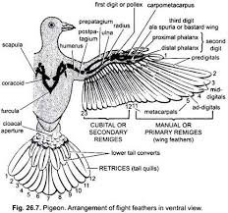
- QUILL or FLIGHT FEATHERS
The quill feathers have a strong rachis or shaft having barbules with an interlocking arrangement. They are classified into following types:
- REMIGES:
- The quill feathers occurring on the wings and serving the purpose of flight are called pinions, wing quills or remiges.
- In remiges the posterior half of the vane is slightly broader than the outer or anterior half.
- Each wing of pigeon has 23 remiges which remain attached to its hinder border.
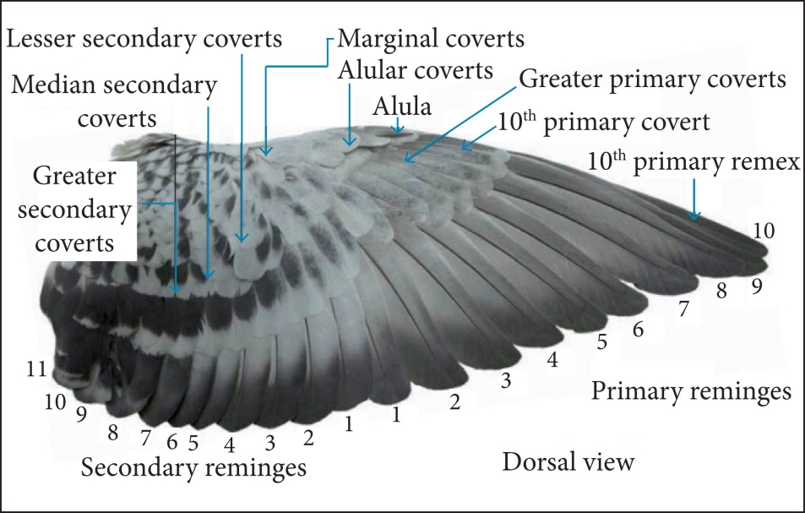
- Out of 23 remiges, 11 are attached to the hand and are called primaries or manuals. The seven of these are attached to the metacarpal region and are called metacarpals. The remaining 4 are attached to the phalanges of 2nd and 3rd digits and are called digitals which are further distinguished into: one ad-digital connected with the single phalanx of 3rd digit, 2 mid-digitals attached with the proximal phalanx of 2nd digit, and 2 pre-digitals with the distal phalanx of 2nd digit.
- The remaining 12 remiges are attached with the ulna of forearm and are called secondaries or cubitals. At the anterior border of the first digit are attached a tuft of feathers called ala spuria or bastard wing.
- RECTRICES:
- The quill feathers occurring around the uropygium to form the tail of pigeon are called tail-quills or rectrices.
- In pigeon, 12 long rectrices are arranged in semicircle or fan-like manner on the tail or uropygium.
- In rectrices two halves of the vane is almost equal in size. The rectrices act as a brake in alighting and as a rudder in vertical or lateral steering.
- COVERTS:
- The quill feathers covering the bases of wing quills and tail quills are called coverts.
- The bases of the wing-quills are covered by several rows of upper and under wing-coverts, and the bases of the tail quills by upper and under tail-coverts.
- They are of smaller size than the quill feathers but both are structurally similar.
- CONTOURS:
- The quill feathers forming the general covering of the body are called contours or pennae.
- They are smaller and wooly feathers having poorly developed barbules due to which barbs can be easily separated.
- These provide warmth and the smooth air flow, without turbulence.
- FILOPLUMES (Hair feathers of pin feathers)
- The filoplumes are small, delicate, hair-like feathers which remain sparsely distributed over the body among the contour feathers.
- A filoplume consists of a short calamus and a long thread-like rachis with a few weak terminal barbs, and barbules without and hamuli.
- DOWN FEATHER or PLUMULE
- The down feathers are small, soft and wooly and lack the rachis but have a short calamus.
- The calamus bears fluffy tuft or barbs which are long, flexible and with short barbules having no hamuli.
- In a young one, the down feathers cover the body and are called nestling down feathers.
- They have a horny sheath covering the quill and basal portions of barbs.
- In adult pigeon, the nestling down feathers is replaced by contour feathers.
- But, they persist as an undercoat beneath the contour feathers in many aquatic birds, such as ducks and swans, serving to increase the thickness of the insulating layer.
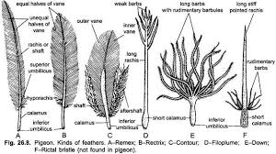

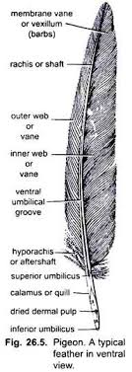
STRUCTURE of a TYPICAL FEATHER
Any contour feather from the general body covering, or a flight feather present on wings or tail, provides the typical structure.
A typical flight feather consists of a supporting central axis or main stem, and an expanded distal portion, the vexillum or vane.
- CENTRAL AXIS
The axis is divided into a basal portion, the calamus and an upper shaft or rachis.
- CALAMUS
- The calamus is hollow, tubular and semi transparent.
- The base of calamus remains inserted into a pit of follicle of the skin.
- The calamus opens below by a small opening called inferior umbilicus, which receives a small, conical, nutritive dermal papilla from dermis.
- The nutrients and pigments are passed through the dermal papilla into the feather from the dermis, during the development of feather.
- Another pore, called superior umbilicus, occurs on the ventral side of junction of calamus and rachis.
- In flight less birds, like cassowary, emu, the after shaft is as long as the main feather, from which it arises.
- In some birds, a small tuft or soft down feather, called after shaft or hypo rachis, occurs near the superior umbilicus and covers it.

- RACHIS
- The part of the axis above the calamus is a rachis.
- It forms the longitudinal axis of the vane.
- It is solid, opaque, roughly quadrangular in transverse section and filled with a closely packed mass of pith cells.
- A longitudinal furrow, the umbilical groove, runs along the ventral or inner surface of the rachis throughout its length.

- VANE
- The rachis bears a fan-like, webbed or expanded membranous part of the feather, the vexillum or vane.
- The vane is divided by rachis into two unequal halves.
- Its proximal part is broader than the distal end.
- Each half of the vane is composed of a series of numerous, parallel, closely spaced, delicate, lateral, thread-like structures called the barbs or rami.
- The barbs arise obliquely outwards from the two lateral sides of the rachis.
- The size of barbs gradually decreases towards both the ends of the rachis.
- Each barb on either side bears a fringe of small, extremely delicate, oblique filamentous processes, the radii or barbules.
- The barbules are of two types: proximal barbules directed towards the base of feather and distal barbules directed towards the tip of the feather.
- The lower edge of the distal barbules bears minute hamuli, barbicels or hook lets and the upper edge of the proximal barbules are deeply curved or rolled to form a groove and flange.
- Hook lets of distal barbules hook over the grooved edges of proximal barbules binding the barbs together.
- With this limited sliding interlocking arrangement, all the barbs and barbules are loosely held together, so that the vane forms a flexible, firm, wide, flat and continuous surface for striking the air during flight.
- The interlocking mechanism can be broken down so that the barbs become separate, but can be joint again by “preening” the whole feather.
- The feathers of ostriches and kiwis lack this interlocking mechanism of feather. The barbs and barbules of after shaft have no hook lets or barbicels.

DEVELOPMENT of a DOWN FEATHER
- The mesodermal tissue of the dermis of delicate and semi-transparent skin of five-or-six day old embryo gather at a place to form a dermal papilla externally covered by epidermis.
- As the dermal papilla grows it takes the shape of a cone whose apex is directed backward.
- The papilla then becomes sunk in a sac called the feather follicle, from which it protrudes as an elongated feather germ.
- Its vascular dermal interior having the dermal blood capillaries, nerves and connective tissues is called feather pulp.
- The feather pulp feeds the growing feather.
- The malpighian layer of distal part of feather germ proliferates in such a way as to form a series of vertical or longitudinal radiating thickenings or ridges, which later separate from one another converting into the rami or barbs.
- The malpighian layer of the epidermis at the base of the feather germ becomes horny, transparent and coherent cylindrical sheath, called periderm, around the growing feather. As the feather grows and expands, the pulp of the distal part of the feather germ is resorbed; the periderm splits and peels off liberating the barbs which are almost parallel to one another and slightly divergent.
- These are attached by their bases to the calamus. On the barbs, the barbules develop by secondary splitting.
- The feather pulp dries inside the calamus to form pith.
- Thus, a rudiment of down feather or plumule is formed. A dermal papilla persists at the base of the feather, to form a new down feather after the shedding of old down feather during ecdysis.
DEVELOPMENT of a CONTOUR FEATHER
- In the development of a contour feather, the feather papilla is formed from the lower or deep end of that of the down feather, so that the earlier down feather drops off from its apex.
- Its early development is the same as in down feather.
- After the feather germ with its feather pulp, longitudinal ridges are not of the same size.
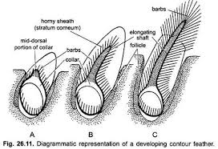
- Instead two mid-dorsal Malpighian ridges thicken and fuse together to form a solid rachis which elongates and grows outwards more rapidly than the rest due to differential growth. As the rachis elongates, it carries up with it the remaining ridges which become the lateral barbs.
- New barbs appear below.
- A similar fusion of two ventral barbs with differential growth results in the formation of hypo rachis or after shaft.
- Later barbules arise from both sides of the barb.
- The periderm splits and dries, the developing feather splits along the mid-ventral line and the barbs flatten out to form the vane.
- The portion of shaft which remains in the skin becomes calamus.
- The original basal aperture becomes inferior umbilicus.
- The superior umbilicus develops later. The feather pulp inside the calamus dries to form the partition like pith.
MOULTING or ECDYSIS
Shedding and replacement of feather is called moulting or ecdysis which takes place gradually, one moulting usually takes an average time of six weeks.
FUNCTIONS of FEATHER
Feather serves a variety of important and decorative functions, some of which are as follows:
- PROTECTION: Feathers provide a light-weight, flexible but resistant and durable body covering which protect the skin from any mechanical or physiological injury.
- HEAT RETENTION: The birds maintain extremely high body temperatures, commonly 104 to 112 F, even in subzero condition. The plumage forms an efficient non-conducting covering with its dead air spaces, useful as insulation.
- ORGAN of FLIGHT: Feathers are light, elastic structure which makes it very light-weight. It also a flexible structure so that the birds can adopt different positions of the body during flight.
- PROTECTIVE COLOURATION or CAMOUFLAGE: Feathers may help to render the bird inconspicuous by their close resemblance to habitual surroundings. This camouflage or protective colouration guards them against their enemies.
- NATAL COVERING: Down feathers act as a natal covering in birds that are born in an advanced stage of development.
- ORNAMENTATION, SEX DETERMINATION and COURTSHIP: On some parts of body, feathers become modified to serve decorative and ornamental functions or utilized in courtship displays. Usually the male birds have more showy feathers than females which help them in attracting the females.

