CANAL SYSTEM IN PORIFERA
All sponges marine or fresh water, possess in their bodies different pores (Ostia) and channels through which water from outside enter inside the body after traversing the whole body and performing various physiological functions is expelled out through a large opening (Osculum), are collectively called Canal System. This system constitutes the most vital system in a sponge body because all the cell types of sponges work centered round this system.
TYPES OF CANAL SYSTEM IN SPONGES
The architectural complexities of the canal system of sponges can be resolved into three main types namely- Asconoid type, Syconoid type and Leuconoid type.
- ASCONOID TYPE
This is simplest form of canal system found in sponges. This type represents a hollow cylinder which remains attached to the substratum by its base.

CHARACTERS

- Simplest type of canal system, found in radially symmetrical vase-like sponges.
- Very thin walled body encloses a large cavity known as spongocoel.
- The spongocoel opens outside by a narrow opening at the summit known as osculum.
- The spongocoel lined by collared cells or choanocytes.
- The wall is pierced by microscopic aperture known as ostia or incurrent pores which extend from the epidermis to the spongocoel.
- Each pore is intracellular i.e., it is a canal through a conical cell known as porocyte and the water current is impelled by choanocytes. The canal through porocyte is known as prosopyle.
WATER FLOW
The flagellated choanoderm creats an unidirectional water flow. The water flow thus enters the ostia, passes over the choanoderm and moves towards the atrium. From atrium water goes out of the body through the Osculum. The circulatory system created here involving the choanoderm, ostia, atrium and Osculum is called an aquiferous system.
The course of water current
Exterior Ostia Spongocoel Osculum Exterior (Water out).
Example: The Ascon type of canal system found in Leucosolenia, Clathrina, Olynthus etc.
- SYCONOID TYPE
In this type surface area has been increased and atrial volume has been decreased by forming alternating in pockets and out pockets of body wall. The out pockets of the choanoderm are termed as choanocyte chambers or radial canals. The in pockets of the pinacoderm are in current canals. In current canals enter into the choanocyte chamber through numerous small opening called Prosopyles.
CHARACTERS
- It is the transitional grade and is above asconoid type between the simplest and complex form.
- The syconoid type of canal system is formed by out pushing the asconoid wall at regular intervals into finger like projections into which radial canals become restricted.
- The radial canals are so arranged that they leave between them tubular space known as incurrent canals.
- The incurrent canals open outside through dermal pores or dermal ostia which are situated in the dermal epithelium.
- As radial canals are formed by pushing outside of the original spongocoel they are lined by choanocytes and are called flagellated canals or radial canals.
- The interior of syconoid sponge is a large spongocoel lined by epidermal epithelium.
- The flagellated chambers open into spongocoel by the pores known as internal ostia or apopyles and its wall contain minute pores leading from the incurrent canals are known as Prosopyles.
- The vase-like syconoid forms contains a large spongocoel which opens outside through a single terminal Osculum.
The course of water current
The water flow in the syconoid aquiferous system usually follows the following route:
Outside ostia in current canal prosopyle choanocyte chamber atrium Osculum outside.
Example: The Sycon type of canal system found in Scypha, Grantia, Grandiopsis.
- LEUCONOID TYPE
The leuconoid type aquires the largest body sizes and the canal system is a complete network of water vessels.

CHARACTERS
- As a result of further out folding of the syconoid type grade II and further thickening of the cortex leuconoid canal system develops.
- Choanocytes of the radial canal evaginate into many small chambers which may repeat the process as a result clusters of small flagellated chambers are formed.
- Mesenchyme fills the space surrounding the flagellated chamber.
- Spongocoel is obliterated and irregular in form.
- The cortex becomes too much thick and is traversed by many in current and ex current canals which again join to form larger excurrent canals to open outside through Osculum.
- Many dermal pores (ostia) lead into incurrent canals than branch irregularly through the mesenchyme. The incurrent canal opens into flagellated chambers through prosopyles.
- The flagellated chamber opens into excurrent canal by apopyle.
Course of water current
Outside ostia in current canal prosopyles flagellated chamber apopyle excurrent canal larger excurrent canal Osculum outside.
Leuconoid canal system presents three stages of evolution, as –a) Euryphalous types, b) Aphodal type and c) Diplodal type.
- Eurypylous Type: When prosopyles opening to radial canal by apopyle and both are present, it is known as Eurypylous type.

Water current
Outside ostia sub dermal space in current canal prosopyles radial canal apopyle excurrent canal Osculum outside.
Example: Leucilla.
- Aphodal Type: When a slender canal namely aphodus is introduced between apopyle and in current canal, it is known as Aphodal type.
Water current
Outside ostia sub dermal space in current canal prosopyles flagellated chamber apopyle aphodus excurrent canal Osculum outside.
Examples: Geodia, Stelklate.
- Diplodal Type: Like aphodus canal a small canal is introduced in between the in current canal and propyle and known as prosodus. In short when both aphodus and prosodus canals are present it is called Diplodal type.
Water current
Outside ostia sub dermal space in current canal prosodus flagellated chamber aphodus excurrent canal Osculum outside.
Example: Spongilla, Oscarella.
MECHANISM of CURRENT PRODUCTIN
To produce an incurrent or cxcurrent condition there are two factors which are essential:
- For entering water through ostia into the body must be a pressure within it less than that in the incurrent canals.
- For escaping water through osculum there must be a pressure within chambers higher than that in the excurrent canals.
But as the pressure in the incurrent and excurrent canals is the same, there must be a difference of pressure within the chamber itself and the lower pressure must be towards the periphery. Such a distribution of pressure is set up when each flagellum causes a flow of water towards the centre of the chamber.
FUNCTION of CANAL SYSTM
- The canal system serves the purpose of nutrition. It is regarded as a highway for the food through the body cells in the radial canal with flagella, which capture the food particles. Water-currents are produced by flagella. Thus, waters flows into the central cavity or spongocoel. Smaller food-particles e.g. diatoms, protozoa and particles of organic debris are ingested into the cells protoplasm and digested. The digestion is intracellular. Robert Grant first of all observed the flow of water in the body-wall by adding powdered carmine to the water. Thus, canal system here does the same functions as circulatory system in higher animals.
- Streaming currents of water have dissolved air, therefore, gaseous exchange or respiration takes place in the cells. Oxygen is taken in by simple process of diffusion and carbon-dioxide is given out. The respiration is also intracellular.
- The function of the canal system is also excretory. Currents of water, which pass outside the osculum remove the carbonic acid and other nitrogenous waste substances, which are the excretory products of the body.
- The purpose of the canal system is also to increase the surface area of the animal in water. This is a characteristic point by which increase of volume is allowed by keeping the ratio of the surface to the volume.
DIFFERENCE BETWEEN the VARIUS TYPES of CANAL SYSTEM
Characters | Asconoid Type | Syconoid Type | Leuconoid Type | Rhagon Type
Wall | Simple. | Evaginated to produce radial and incurrent canal. | Irregular. | Simple.
Mesenchyme | Simple and thin. Completely traversed by porocytes. | Thickened and not completely traversed by porocytes. | Highly elaborated, traversed by incurrent canals or sub dermal spaces. | Considerably thickened, traversed by incurrent canals and sub dermal spaces.
Choanocytes | Limited in the spongocoel. | Limited in the radial canals. | Limited in the flagellated chambers which open by narrow apopyles. | Limited in the flagellated chambers which open by wide apopyles.
Spongocoel | Spacious. | Spacious. | Usually obliterated. | Spacious.

Fig: Ascon type, Sycon type and Leucon type of Canal system.
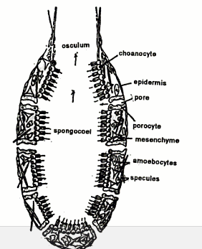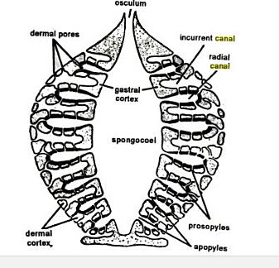
Fig: Ascon type (left) & Sycon type (right) of canal system.
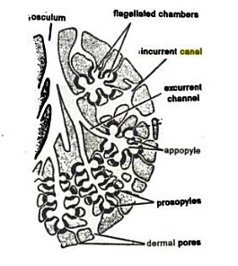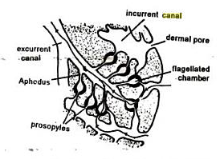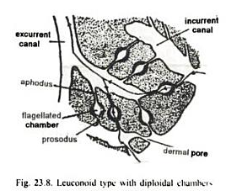
Fig: Varous types of Leuconoid type canal system. Euryplous type (left), Aphodal type (middle) & Diplodal type (right).

